**Chapter 3 Experiment 1: coarticulated tone production**

Experiment 1 measures tone productions in monosyllabic and disyllabic words in Taiwan Mandarin and Taiwan Southern Min. This experiment seeks to reexamine the magnitudes and behaviors of tonal coarticulations in these two languages.

While it is established in the literature that the pitch values of Mandarin tones are subject to those of their preceding (carry-over effects) and following tones (anticipatory effects), with carry-over effects being stronger and assimilatory, and anticipatory effects being weaker and generally dissimilatory, studies on tonal coarticulation in (Taiwan) Southern Min lead to less consistent results: while Peng (1997) found anticipatory tonal coarticulation in Taiwan Southern Min, and H. Wang (2002) stronger carry-over effects and weaker anticipatory effects, Chang & Hsieh (2012) found inconsistent assimilatory and dissimilatory effects for both carry-over and anticipatory coarticulations. This might be due to the different experiment designs and dialects examined: in H. Wang (2002), non-words were used as stimuli, with syllables also found in Taiwan Mandarin. Such design might have led the speakers to be influenced by Mandarin, in which they were presumably also native; in Chang & Hsieh (2012), it was Malaysian Hokkien that was examined, while in Peng (1997) and H. Wang (2002), it was Taiwan Southern Min. A reexamination with a consistent design is thus in need if we are to compare tonal coarticulations in these two languages, and to observe how the differences in tonal coarticulations may exert different effects on the way the speakers of the two languages normalize for them perceptually.

**3.1 Methods**

3.1.1 Participants

This study recruited 43 Taiwanese college students as participants (25 females; 20– 27 y.o., mean=21.93). 15 of them were native speakers of Taiwan Mandarin. These subjects were not speakers of Taiwan Southern Min (upon self-report). These speakers are hereafter referred to as the monolingual group. 28 of them were native speakers of Taiwan Southern Min. These subjects were also speakers of Taiwan Mandarin. These speakers will be referred to as the bilingual group. Among the bilingual speakers, 11 speakers were advanced Taiwan Southern Min speakers, with self-reported points of 8 or higher on a fluency scale from 1–10. These 11 speakers will be referred to as the advanced bilingual group. The rest of the bilingual speakers will be referred to as the intermediate bilingual group. All of the subjects were not speakers of other tonal languages. See Appendix 6 for a full list of the participants.

For Experiment 1, only the monolingual speakers[1] and the advanced bilingual speakers participated. The monolingual speakers produced the Mandarin stimuli; the bilingual speakers produced both the Southern Min and Mandarin stimuli.

3.1.2 Stimuli

To examine the influence of ambient tones on the target tones, a disyllabic word was chosen for each of the 16 (4 tones × 4 tones, for Taiwan Mandarin)/25 (5 tones × 5 tones[2], for Taiwan Southern Min) tone combinations as stimuli. Syllables with voiceless obstruents, affricates or fricatives were avoided. In addition, to observe the tones in neutral positions , 4 monosyllabic words with the 4 tones were chosen for Taiwan Mandarin group, and 7 monosyllabic words likewise for Taiwan Southern Min group. These resulted in a total of 20 words for Taiwan Mandarin group and 32 words for Taiwan Southern Min group, with 10 repetitions each. See Appendix B.1 for a full list of the stimuli.

3.1.3 Apparatus

The audio data were collected with a microphone (Audio–Technica Carcoid AT2035) plus a portable audio interface (USBPre 2), and saved as WAV files, with a sampling frequency of 44100 Hz.

3.1.4 Procedure

Subjects were first led through a list of the stimuli which they would encounter, and made sure they were familiar with the words. The stimuli were then randomly presented on a MacBook Pro (13-inch, 2018) one at a time. For Taiwan Mandarin group, stimuli were presented in traditional Chinese characters; for Taiwan Southern Min group, stimuli were presented in both traditional Chinese characters and romanized forms, with their Mandarin glosses underneath. Subjects were asked to say the word when they saw it, at a relaxed pace. Subjects might press the button and proceed to the next word when they were ready. The stimuli were divided into two blocks in the Taiwan Mandarin version and six blocks in the Taiwan Southern Min version, with a break in between. The whole process would take about 10 minutes for Taiwan Mandarin group and 30 minutes for Taiwan Southern Min group. This experiment was done after Experiments 2 and 3.

3.1.5 Data processing

3.1.5.1 Labeling

The audio data were examined and processed with Praat (Boersma & Weenink, 2018). Syllable boundaries were labeled and saved as Praat TextGrid. Boundaries were determined with intensity and formant transition. A part of the TextGrids is shown below in Figure 3.1.

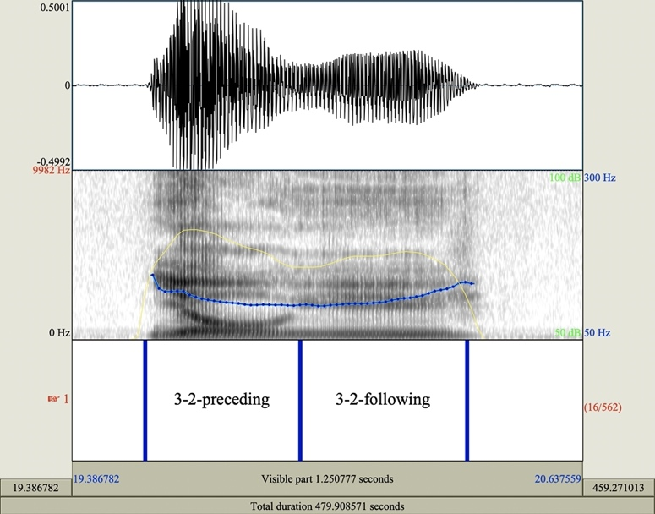

Figure 3.1: Example of TextGrid labeling.

3.1.5.2 Pitch extraction

F0 values were extracted using Praat, Parselmouth (Jadoul et al., 2018), and TextGridTools (Buschmeier & Włodarczak, 2013) on Python 3.9 (van Rossum & Drake, 2009). The time step was 0.01s. The pitch ceiling and floor values were determined individually for each tone for each subject. To avoid possible failure to capture the F0 value for every time step, principally due to creaky voicing or extra-low pitch, for each tone production, the F0 values were divided into 11 proportions, missing values in a proportion were ignored, and the mean of the F0 values in each proportion was calculated. If all values in a proportion were missing, this proportion was discarded; if more than 3 of the 11 time points were discarded, this tone production was discarded. After all F0 values were extracted, they were converted to z-transformed semitones to make cross-subject comparison. 4.04% of Taiwan Mandarin and 7.85% of Taiwan Southern Min tokens were discarded.

3.1.6 Analyses

3.1.6.1 Pitch contour comparison

For visualization and direct observation, F0 data were fitted through generalized additive mixed models (GAMMs; Wieling, 2018) with R Core's (R Core Team, 2019) lme4 package (Bates et al., 2015).

3.1.6.2 Tonal coarticulation

To quantify the magnitude of tonal coarticulation, the pitch onsets and offsets were first calculated. These were determined as the F0 means of the first and last 9.0% (i.e. the first and last of the 11 time points mentioned in Section 3.1.5.2) of each tone production, with missing values ignored. Linear mixed-effect models were fitted with R Core's (R Core Team, 2019) lme4 package (Bates et al., 2015). Several candidate models were compared according to their AIC scores. The chosen models had as the fixed effects the values of preceding offsets (in the case of carry-over coarticulation)/following onsets (in the case of anticipatory coarticulation, shown as x in the code), language (Taiwan Mandarin (monolingual) vs. Taiwan Mandarin (bilingual) vs. Taiwan Southern Min), and tones[3]. Participants were taken as random intercepts, with a random slope of x plus the interaction of onset and offset segment types[4] on each level each of participant. The formula is shown below[5]:

model <lmer(y ~ x*language*tone + (x + onset_segment_type* offset_segment_type|participant))

In order to compare the magnitudes of carry-over and anticipatory effects within each of the two languages, other two models were fitted, with the fixed effects being the onset/ offset values, positions (carry-over vs. anticipatory), and tones, and the same random effects as in the previous models.

model <lmer(y ~ x*position*tone + (x + onset_segment_type* offset_segment_type|participant))

In this study, significant results (p<.05) were taken as indicator of existence of tonal coarticulation; positive coefficients were taken as indicator of assimilatory effects, and negative ones indicator of dissimilatory effects.

**3.2 Results**

3.2.1 Tone contours

Tone contours of Taiwan Mandarin and Taiwan Southern Min tones in carryover and anticipatory positions are shown in Appendix C.1.

3.2.2 Directionalities and magnitudes of coarticulatory effects in the two languages

Tonal coarticulation of Taiwan Mandarin and Taiwan Southern Min in carry-over and anticipatory positions respectively are shown in figures 3.2 and 3.3. In general, tonal coarticulations in the two languages are identical. For both languages, in both positions, the ambient tones were shown to exert positive impacts (both p<.001***) on the target tones, that is, a high ambient tone raised, and a low ambient tone lowered the target tone. This meant that in both languages, both the carry-over and anticipatory effects were assimilatory, and no differences of magnitude of the carry-over effects between the two languages or the anticipatory effects between the two languages were found (p=.31/.65, respectively).

However, difference in magnitudes between the two effects were found in withinlanguage comparisons. In both Taiwan Mandarin and Taiwan Southern Min, the carryover effects were stronger than the anticipatory effects (p=.01* in Taiwan Mandarin and p=.004** in Taiwan Southern Min) .

No significant differences between monolingual and bilingual group’s Taiwan Mandarins were found.

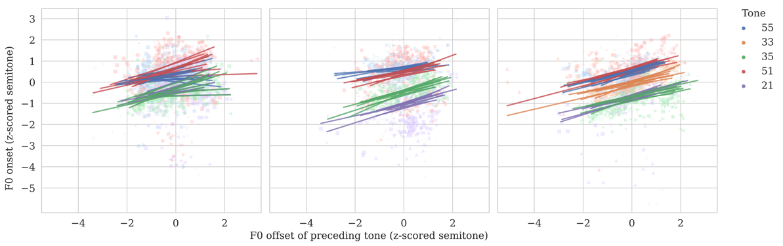

Figure 3.2: Fitted LMM model of tone onsets and offsets in carry-over positions (left: Taiwan Mandarin (monolingual); middle: Taiwan Mandarin (bilingual); right: Taiwan Southern Min). 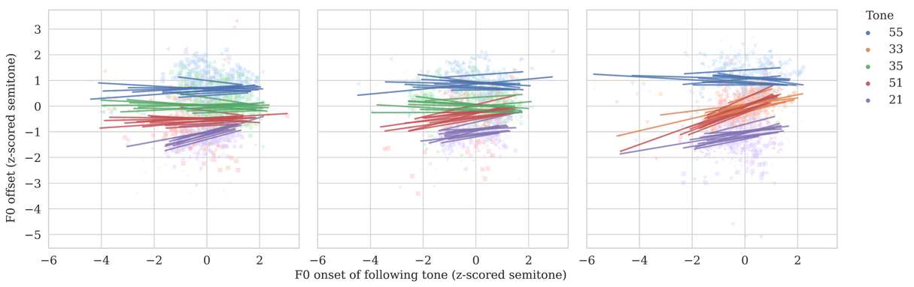

Figure 3.3: Fitted LMM model of tone onsets and offsets in anticipatory positions (left: Taiwan Mandarin (monolingual); middle: Taiwan Mandarin (bilingual); right: Taiwan Southern Min).

In general, tonal coarticulations in Taiwan Mandarin and Taiwan Southern Min were identical in both directionality and magnitude. In both languages, both the carry-over effects and anticipatory effects were assimilatory, with the former being stronger, and the later weaker. Rather symmetric patterns were therefore found in the two languages. This can be summarized in table 3.1.

|  |  |  |
| --- | --- | --- |
|  | Magnitude | Direction |
| Carry-over | Stronger | Assimilatory |
| Anticipatory | Weaker |

Table 3.1: Distribution of tonal coarticulation in Taiwan Mandarin and Taiwan Southern Min.

**3.3 Discussion**

3.3.1 Typological singularity of tonal coarticulation in Taiwan Mandarin and Taiwan Southern Min

As reviewed in Section 2.1, previous studies generally showed an asymmetry of Mandarin tonal coarticulation in both magnitude and directionality. A prevalent belief is that carry-over effects in (Beijing) Mandarin is stronger and assimilatory, while anticipatory effects are weaker and dissimilatory. This means that (Beijing) Mandarin is in alignment with the typological asymmetric distribution of tonal coarticulation. However, while the carry-over effect in Taiwan Mandarin was indeed found to be assimilatory and stronger than the anticipatory effect, linear-mixed effect models revealed that the anticipatory effects were also assimilatory as the carry-over effects. On the other hand, our results are in alignment with the findings of Peng (1997) and Wang (2002), both finding assimilatory anticipatory effects in Taiwan Southern Min. This suggests that both Taiwan Mandarin and Taiwan Southern Min are typologically singular, having more symmetric distribution of tonal coarticulation as compared with typological distributions.

In Chang & Hsieh (2012), it is suggested that the uncommon distribution seen in Malaysian Hokkien and Taiwan Southern Min may be attributed to final prominence in the two languages. In both languages, rich tone sandhi rules are applied, where the tone of the preceding syllable undergoes sandhi rules before another syllable. The authors argue that such sandhi rules put more emphasis on the second syllable, and as a result may serve to balance out the natural rightward bias of speech linearity, contributing to more symmetric tonal coarticulatory effects.

While Taiwan Mandarin does not apply such rich tone sandhi rules, it is likely that Taiwan Mandarin might to a certain extent be under the influence of Taiwan Southern Min, and in turn lead to this dialectal difference we see between the data collected in this study and the results in previous researches of Mandarin, where the investigated dialects were all Beijing Mandarin. It is established that Taiwan Mandarin and Taiwan Southern Min as the two major languages in Taiwan, have profound interaction and mutual influence on virtually every linguistic level, including morphosyntax (e.g., J.-C. Li, 2008) and phonlogy (e.g., Chuang & Fon, 2010; S.-H. Li, 2010), and code-switching between the two languages are more than common in Taiwanese society (cf. Yang, 2021). Scholars including Her (2012) and Su (2018) also argue that Taiwan Mandarin is a highly unique localized variety of Mandarin, under the influence of Taiwan Southern Min and other Taiwanese languages[6]. It is not inconceivable that Taiwan Mandarin might come under the influence of the final prominence we observe in Taiwan Southern Min and Malaysian Hokkien, and as a consequence has more symmetric distribution as seen in Taiwan Southern Min.

Another possibility is that the discrepancy we see between Taiwan Mandarin and Beijing Mandarin might be due to inherent prosodic differences. Taiwan Mandarin is more syllable-timed than Beijing Mandarin. Intuitively, the fact that Taiwan Mandarin speakers put more equal emphases on the two syllables may well act to counter the rightward bias mentioned previously, which can also result in a more symmetric distribution. This, however, would require further investigation.

3.3.2 Tone inventory sizes and possible perceptual confusion of coarticulated tones

Another finding of this experiment is that there were no significant differences of magnitudes of coarticulatory effects in the two languages. This is an interesting result, seeing that the two languages have very different sizes of tone inventories. As mentioned in Section 1, while Taiwan Mandarin has only four tones, Taiwan Southern Min has seven tones. It is not hard to imagine that under tonal coarticulation, the odds of confusing one lexical tone with another would be much higher in Taiwan Southern Min than in Taiwan Mandarin. The fact that Taiwan Southern Min had similar amount of tonal coarticulation may suggest that such phenomenon may be a universal constraint that cannot be voluntarily manipulated. Particularly, one may assume that there would be different perceptual strategies for Taiwan Mandarin and Taiwan Southern Min speakers to tackle with the possible confusion caused by tonal coarticulation. In the next two experiments, we will investigate such issue.

1. Except for P22, who only participated in Experiments 2 and 3.
2. Check tones were excluded.
3. To make inter-language comparisons, tones were converted into five-level surface tones (i.e., tone realization after tone sandhi). Two different sets of tone sandhi rules were applied for Taiwan Southern Min T5’s due to dialectal differences. P25, P32, P36, and P39 applied the sandhi rule of 𝑇5(35) → 𝑇3(21), others applied the rule of 𝑇5(35) → 𝑇7(33).
4. While the segments in the stimuli used in this experiment were all voiced, segment types were taken into consideration as some segments were found to affect F0 (Hanson, 2009). The segments were categorized into four types: vowels (including glides), liquids (including voiced affricates), nasals, and obstruents.
5. In the case of carry-over coarticulation, *y* is the values of the following onsets; in the case of anticipatory coarticulation, it stands for the values of the preceding offsets.
6. Her even goes as far to say Taiwan Mandarin is a new-born creole unique to Taiwanese people.